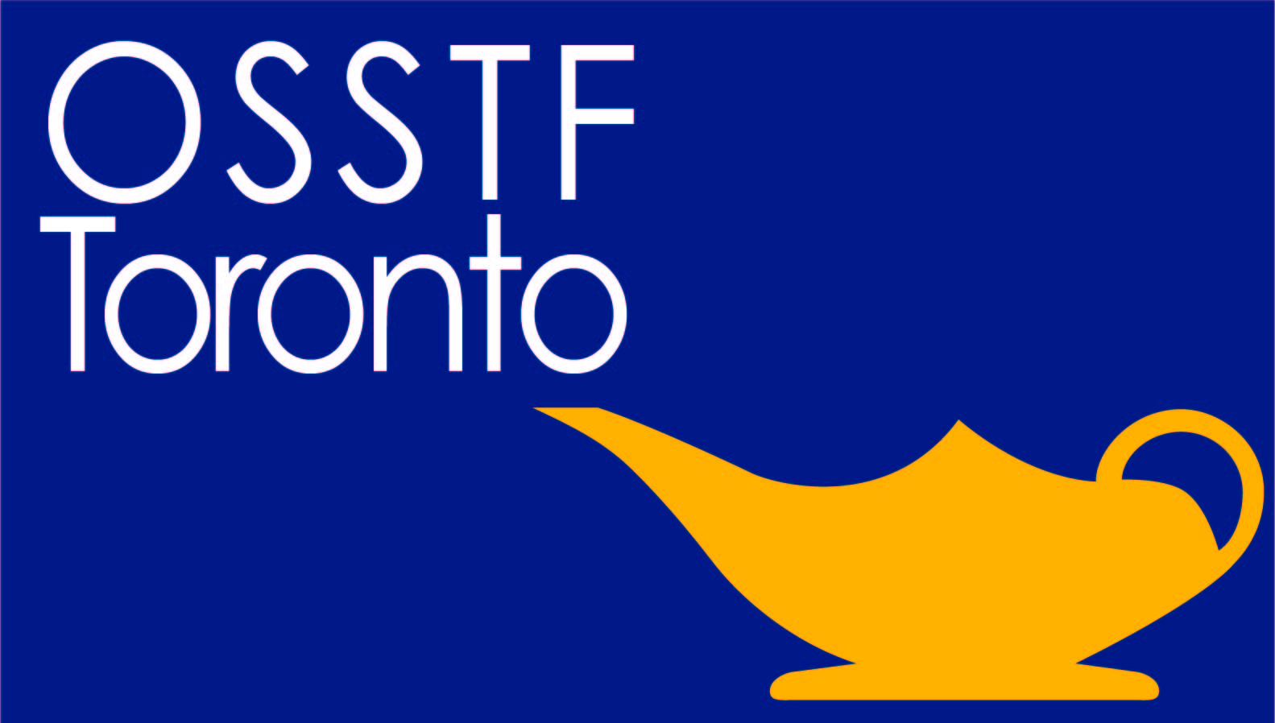
Please Post and Share

The OSSTF Toronto Gay Straight Alliance, along with our sisters & brothers at ETT invite you to join us for lunch,

Saturday July 2, 2016,

before the annual Pride Dyke March

Time: 12:30- 1:45 pm
March begins at 2 pm Church Street and Charles Street
Location: Spirits Bar & Grill
(642 Church St, Church & Hayden south of Bloor)

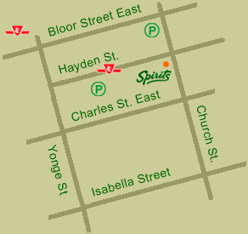

All OSSTF Toronto Members & Friends/Family Welcome
Refreshments provided

For further details contact Lisa Black-Meddings lblack-meddings@osstfd12.com

